STANDARD FORMAT OF “LEHENGA DESCRIPTION”


For Online Selling Products
Design Name: GULAL-B
Product Colours NO.: B3

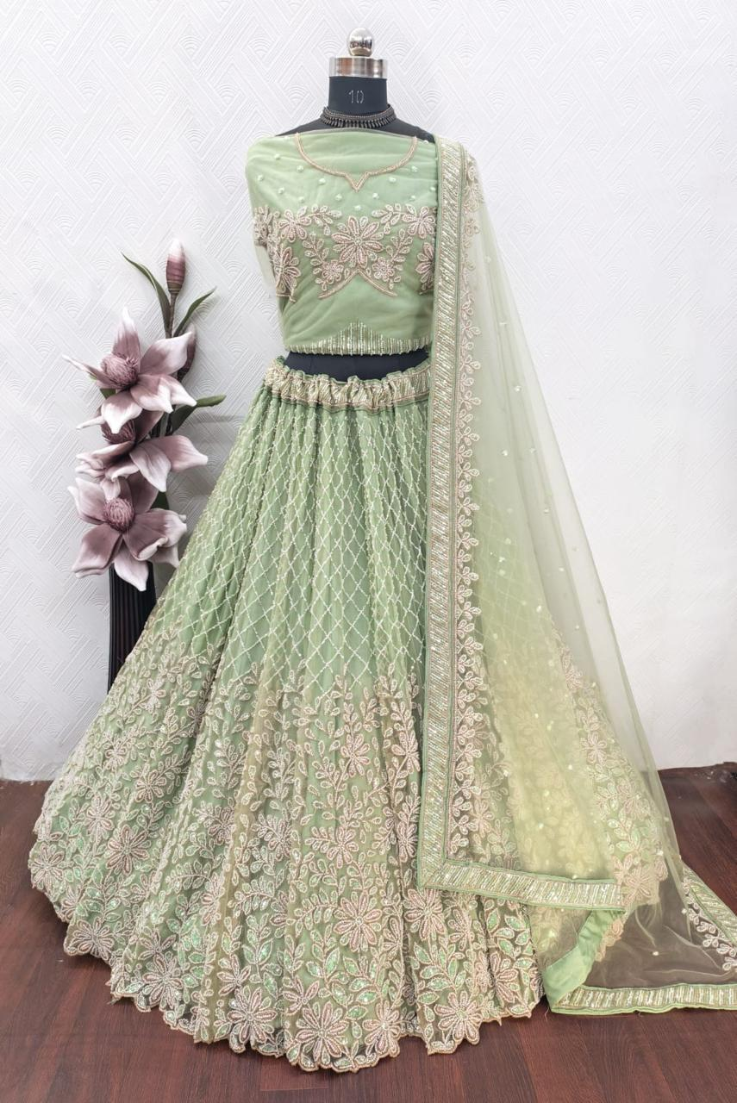
Particulars | Details
Lehenga Fabric | Net
Blouse Fabric | Net
Dupatta Fabric | Net
Work Type | Beads
Colour | Pista
Pattern | Girlish
Stitching Type | Semi-Stitched (Can be customized up to 44")
Occasion | Reception, Engagement & Festive Wear
Fit Type | Regular Fit
Care Instructions | Dry Clean Only
Package Contents | 1 Lehenga, 1 Blouse Piece, 1 Dupatta

KEY HIGHLIGHTS
- Crafted from premium net fabric for a lightweight and elegant look
- Beautifully embellished with beads work that adds sparkle and charm
- Designed in a stylish pattern, perfect for modern festive styling
- Semi-stitched design allows easy customization up to size 44
- Regular fit ensures comfort with a graceful silhouette
- Ideal for receptions, festive occasions, and celebration wear
- Easy to maintain with dry clean only care instruction

